 | Clinical Note |  | :
 | Indication of Test |  | :
 | Index Case |  | : |  | Name  Relationship: | HBAna Code:
Parameter | Result | Flag | Unit | Reference Range
WBC |  |  | 10^9/L | 4-10
RBC |  |  | 10^12/L | 3.8-4.8
HGB |  |  | g/L | 120-150
HCT |  |  | L/L | 0.36-0.46
MCV |  |  | fL | 83-101
MCH |  |  | pg | 27-32
MCHC |  |  | g/L | 315-345
PLT |  |  | 10^9/L | 150-400
RDW-CV |  |  | % | 11.6-14
Reticulocytes % |  |  | % | 0.5-2.5
Reticulocytes |  |  | 10^9/L | 50-100
Retic. He |  |  | pg | 30.3-35

 | Iron Profile
 | Parameter | Result |  |  |  |  |  |  |  | Flag | Unit | Reference Range
 | Serum Iron
 | UIBC
 | TIBC
 | Ferritin
 | sTfR
 | Hb Quantitation
 | Capillary Electrophoresis
Zone | Result(%)
Hb A
Hb A2
Hb F
Other Variants

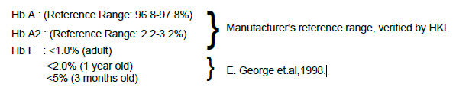
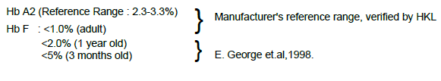
High Performance Liquid Chromatography
Peak | RT(min) | Area(%)
Hb A
Hb A2
Hb F
Other Variants

 | RBC Morphology |  |  | :
 | H Inclusion |  |  | :
 | Sickling Test |  |  | :
 | Gel Electropheresis
 | Alkaline pH 8.5 |  |  | :
 | Acid pH 6 |  |  | :
 | Impression |  |  | :
 | Suggestion |  |  | :
 | HbAna Code |  |  | :
 | Disclaimer |  |  | : |  |  | 1 . Result is not valid in a post transfusion sample.  2. Hb analysis as done with the above methods do not exclude alpha thalassemia trait and normal Hb A2 beta thalassemia trait.
Notification Information |  | :
Notified to…..
Reported by |  |  |  |  |  | : |  |  |  |  |  | (Signature & Stamp)
Reported Date & Time |  |  |  |  |  | :
Validated by |  |  |  |  |  | :
Validated Date & Time |  |  |  |  |  | :
Amendment Reason |  |  |  |  |  | :
Amendment Entered by |  |  |  |  |  | :
Amendment Validated by |  |  |  |  |  | :
Amended Date & Time |  |  |  |  |  | :

