BCP LABEL TEMPLATE

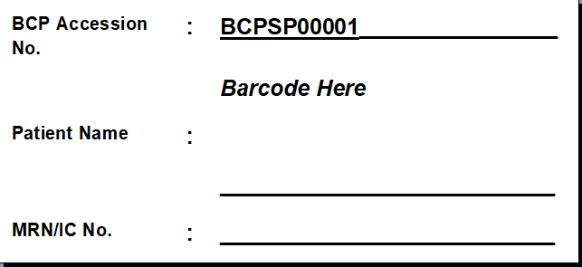
Figure 1 Accession Label Template
BCP Accession No format: BCPSP, BCPFS, BCPAU1, BCPAU2

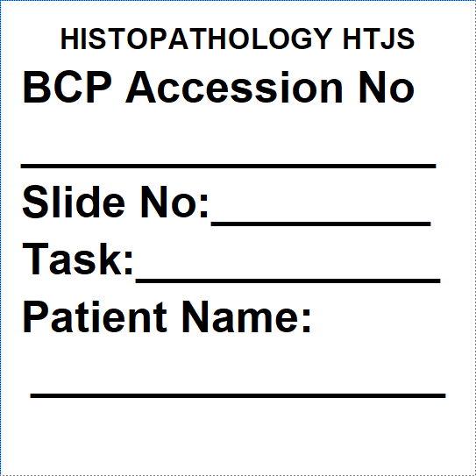
Figure 2 Slide Label Template

