Lab. No.
BCP LIS: SECTION 1 – CASE DETAILS
**Please refer to the attached PERPAT form
BCP LIS: SECTION 2 – ACCEPTED DETAILS
2.1 | Accepted by  (Name & Role)
2.2 | Accepted Date & Time
2.3 | Performed By  (Name & Role) |  |  |  |  | MLT |  |  |  | SO |  |  |  |  | Pathologist
2.4 | Performed Date & Time
BCP LIS: SECTION 3 – TEST PURPOSE
TEST PURPOSE
3.1 | New |  | In Treatment |  |  |  |  | Contact |  |  |  |  |  | Under Supervision |  |  |  |  | Others
BCP LIS: SECTION 4 – SLIT SKIN SMEAR
SMEAR RESULTS
4.1 | Site |  |  |  | Density |  |  |  |  |  |  | Solid |  |  |  |  | Fragmented
4.1 | 1
4.1 | 2
4.1 | 3
4.1 | 4
4.1 | 5
4.1 | 6
4.1 | BI
4.1 | MI
4.1 | 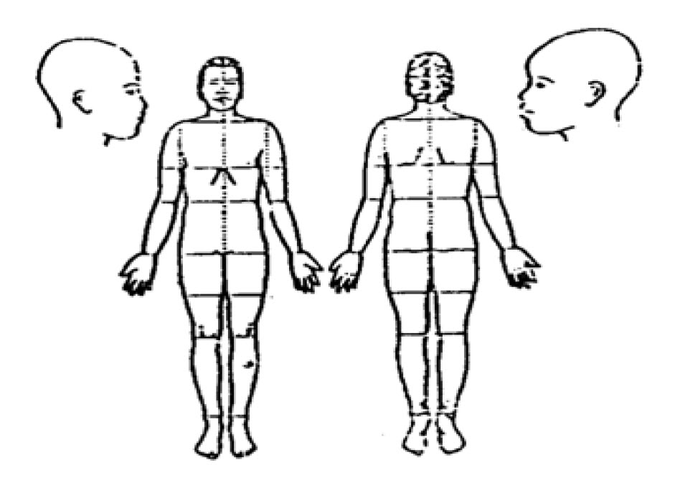
NOTIFICATION DETAILS *Note: Strike out whichever is not applicable
1. | Method* |  |  |  |  | PHONE | FAX | EMAIL
2. | Informed to  (Name & Role) |  |  |  |  |  |  |  |  |  |  |  | 3. | Informed Date & Time
4. | Notified by  (Name & Role) |  |  |  |  |  |  |  |  |  |  |  | 5. | Read Back* |  |  |  | YES | NO
6. | Remarks
BCP LIS: SECTION 5 – VERIFICATIONS
Verified By (Laboratory Staff):  (signature /name/stamp) |  |  |  |  |  |  |  |  | Verified by (Head of Unit):  (signature /name/stamp)
Date & Time: |  |  |  |  |  |  |  |  | Date & Time:

